1. **Introduction**

**1.1 Motivation**

The mouse is one of the important inventions in computer world which improved human machine interactivity. In present scenario, wireless and Bluetooth embedded mouse technology is developed but it is not that ideal to use as this technology is not completely hands free. In Bluetooth technology the mouse developed requires power such as battery power or connecting devices like dongle.

By adding these extra components to the mouse the cost increases and it is also not user friendly to use. So, in the proposed model these limitations are removed and interaction is made user friendly as well as cost is also reduced. This model is actually a virtual mouse system using hand gestures with the help of computer vision.

**1.2 Definition**

The primary aim of this project is to improve human and computer interaction by developing an effective and alternative way of controlling the cursor and its various functions such as left click, right click, scroll up, scroll down and selection.

With the help of this model a user can easily interact with the system/computer without the use of an external device. It also allows the user to interact with system from a considerable distance. And because of this improvement the essential hardware required for the computer/laptop is also reduced.

This model makes use of the webcam to capture the video feed, which is used for image processing, and now a days webcam is an essential device/hardware for a laptop/computer and therefore it is not considered as an extra hardware.

**1.3 Objective**

The objective of this project is to improve the usability and experience of the users by providing a better machine and human interaction. The Image/Video feed from the webcam is used to track and detect gestures and mapping those unique gestures to different mouse events.

Retrieve the image data from the webcam and convert it to a usable format and use it as input. The image must be filtered to identify different colors. Make contours and find the mean positions of those contours. Track those mean positions to recognize the gestures. Map those gestures to different mouse actions and use them.

**2. LITERATURE SURVEY**

**2.1Existing System**

|  |  |  |  |  |
| --- | --- | --- | --- | --- |
| **S.no** | **Year** | **Name** | **Authors** | **Algorithms used and Drawbacks** |
| 1 | 2020 | Virtual Mouse Using Object Tracking | Prof. Monali Shetty , Christina Daniel, Manthan Bhatkar | Hvm,Svm algorithms are used.Time taken to detect is nearly 20 sec |
| 2 | 2020 | Gesture Recognition Based Virtual Mouse | Sugnik Roy Chowdhury, M.D. Anto Praveena | Convex Hull algorithm is used.Accuracy is 75-85%  Continuous finger movement results in stress in fingures |

|  |  |  |  |  |
| --- | --- | --- | --- | --- |
| 3 | 2019 | Design and Development of Hand Gesture Based Virtual Mouse | Kabid Hassan Shibly, Samrat Kumar Dey | Computer Vision is used.  Less accuracy and system recognition of colours is poor. |
| 4 | 2019 | Virtual Mouse Control by Webcam for the Disabled | Reyhan Seher, Mazlum unay | Eye ball Tracking using matlab. Eye blinking may occur random |
| 5 | 2019 | Cursor Control Using Eye Ball Movement | Vandana Khare, S.Gopala Krishna | Pupil movement detected using open source computer vision. The eye movement converted into voltage and time graph, normal webcam can’t be used. |

Table 2.1 Existing System

**2.2 Proposed System**

The model/system that we proposed is a cursor control model using image processing, which takes hand gestures that are being captured from a webcam as an input in HSV format and by detecting the centers of the color contours thereby detecting the gestures, it performs mouse events and mouse movements. We use three standard colors which are represented on three fingers of a hand to detect the gestures.

Python, PyAutoGui and OpenCV (cv2) library is used to implement this model for Hand gesture tracking. This system is easy to use and it is also easy to remember the gestures that are provided to perform different operations. And once the Model is deployed on the system, we can use this version of the mouse all the time.

**3. SYSTEM ANALYSIS**

* 1. **Functional Requirements Specifications**

After analysing the project objective, we have come up with following modules:

* **Color Calibration:**

With the help of Computer vision (Opencv2), we recognised three standard colors and converted them into HSV format using cv2.convert() function and calibrated the colors. Users can dynamically adjust hue, saturation, value of the colors.

* **Centroid Detection:**

Fromthe output of the color calibration module, we calculate a mean point which represents contour of each color. With these centroid points we detect the type of gesture position made by user.

* **Multiple Gesture Recognition:**

By the position and movement made by the user various gestures are recognised, if any gesture is not recognised by the system model then it considers it as free movement of the mouse cursor with help of only one color.

* **Mouse Events and Movement:**

Based on the gestures recognised by the model equivalent mouse events are performed with the help of ‘Pyautogui’, a python library.

* 1. **Software Requirements**
     + 64-bit Operating System: Windows 7 or Higher
     + Jupyter Notebook/ Google Colab
     + Python version >3.0
     + PyAutoGUI
     + OpenCV

**3.3 Hardware Requirements**

* + - * A Good Webcam
      * RAM preferably >8GB for faster processing
      * GPU
      * Memory space >500GB

**3.4 Environmental Specifications**

* A will lit room with mostly light and pale colors.
* No other objects should be present in front of the webcam (particularly red, yellow blue colored objects) except colors on the user’s hand.

**4. SYSTEM DESIGN**

**4.1 Architecture of Proposed System**

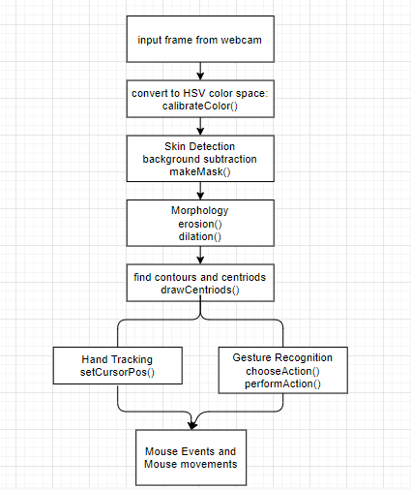

**Fig 4.1 : Architecture Diagram**

**4.2 UML Diagrams**

**4.2.1 Use Case Diagram**

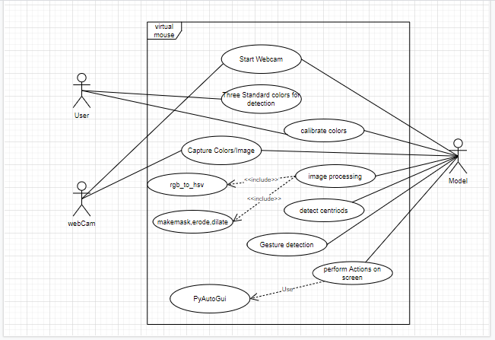

**Fig 4.2.1 : Use Case Diagram**

**4.2.2 Class Diagram**

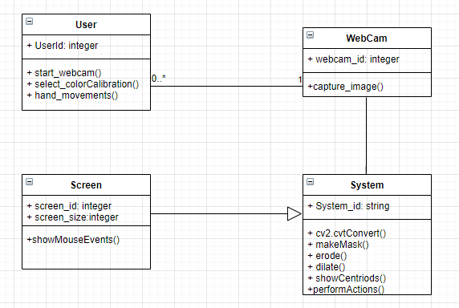

**Fig 4.2.2 : Class Diagram**

**4.2.3 Sequence Diagram**

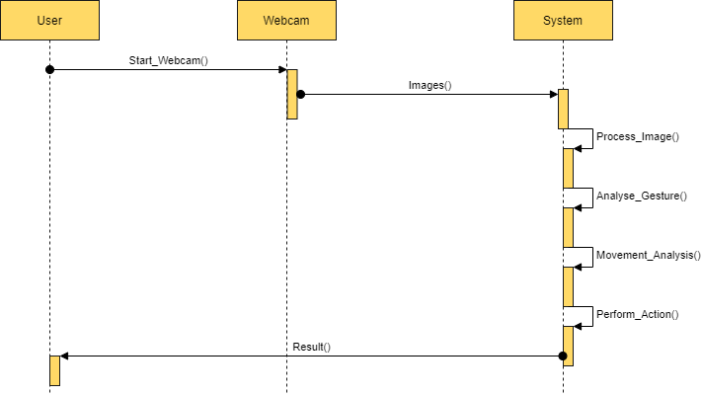

**Fig 4.2.3 : Sequence Diagram**

**4.2.4 Activity Diagram**

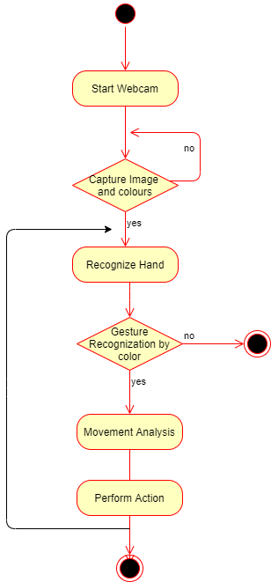

**Fig 4.2.4 : Activity Diagram**

**5. Implementation**

* 1. **Methodology**

**5.1.1 Concept**

HSV color space - a cylindrical color model that remaps the RGB primary colors into 3D (hue, saturation, and value). Hue specifies the angle of the color on the RGB color circle. A 0° hue results in red, 120° results in green, and 240° results in blue. Saturation controls the amount of color used. A color with 100% saturation will be the purest color possible, while 0% saturation yields grayscale. Value controls the brightness of the color. A color with 0% brightness is pure black while a color with 100% brightness has no black mixed into the color.

**5.1.2 Implementation of Model**

In this model we recorded the image from webcam and converted it from RGB to HSV color format. Then user required to calibrate the three colors i.e, red, yellow, blue in the image which consists of user hand with three colors on fingers individually. In this model we used calibrateColor() function to calibrate the three colors individually by the function. The user can manually calibrate the colors by adjusting the Hue, saturation, value ranges or they can choose default values.

From these calibrated individual images the three fingertips where the color band lies are extracted from user hand, in the video captured by webcam, using the cv2.inRange() function i.e. contours are detected. Noise is removed by applying morphism which contains two steps erosion and dilation. The output images are free from noise and are termed as ‘mask’, and from these images the centroids are calculated.

As a webcam is not ideal, so the noise of the background is also captured in the image and also the vibrations of the user may also get captured. Due to these vibrations of the user hand the centroids keep varying about a mean position which reduces the efficiency of the model. In order to increase the efficiency and differentiate the actual movements from vibrations, we used an enhanced formula to handle the noise caused by vibrations.

The function chooseAction is used to calculate the three centroids, which is used to decide the functions to be performed by the mouse based on the positions of the three centroids. Based on the action returned by chooseAction() function, we use performAction() function to perform the equivalent mouse events and movements using PyAutoGUI library which can be implemented in python environment. The actions that need to be performed by the system are:

* free cursor movement
* scroll up
* scroll down
* left click
* right click
* drag/select

**5.1.3 Noise rate formula**

To deal with the noise caused by unwanted vibrations we use following method- first we compare the new position of the centroid with the previous position. If the difference between them is less than 5 pixels, we considered that it occurred due to noise.

If the difference between them is more then it is done by user voluntarily, so the cusor position is changed accordingly by this function.

* To set cursor position, if the cursor movement is voluntary then

Position = centriod + (learning rate)*(previous_pos - centriod)

* if the cursor movement is because of vibration of hand or involuntary then

Position = centriod + (learning rate)*(previous_pos - centriod)

|  |  |  |  |  |  |
| --- | --- | --- | --- | --- | --- |
| **S.No.** | **Mouse Event** | **Pixel Difference** | **Description** | **Learning Rate** | **Sensitivity** |
| **1** | Cursor Movement | **< 5** | **Voluntary**  **Hand Movement** | **0.7** | **Ideal** |
| **2** | Cursor Movement | **< 5** | **Voluntary**  **Hand Movement** | **0.8** | **Ideal** |
| **3** | Cursor Movement | **< 5** | **Voluntary**  **Hand Movement** | **0.9** | **High Sensitivity** |
| **4** | Cursor Movement | **< 5** | **Voluntary**  **Hand Movement** | **1.0** | **High Sensitivity** |
| **5** | Cursor Movement | **< 5** | **Voluntary**  **Hand Movement** | **0.6** | **Low Sensitivity** |
| **6** | Cursor Movement | **>5** | **Vibrations/Noise** | **0.1** | **Ideal** |
| **7** | Cursor Movement | **>5** | **Vibrations/Noise** | **0.0** | **High Sensitivity** |
| **8** | Cursor Movement | **>5** | **Vibrations/Noise** | **0.2** | **Low Sensitivity** |
| **9** | Cursor Movement | **>5** | **Vibrations/Noise** | **0.3** | **Low Sensitivity** |

**Table 5.2 Learning rate for Cursor Movement**

**5.2 Results/Screenshots**

**5.2.1 Calibration of colors**

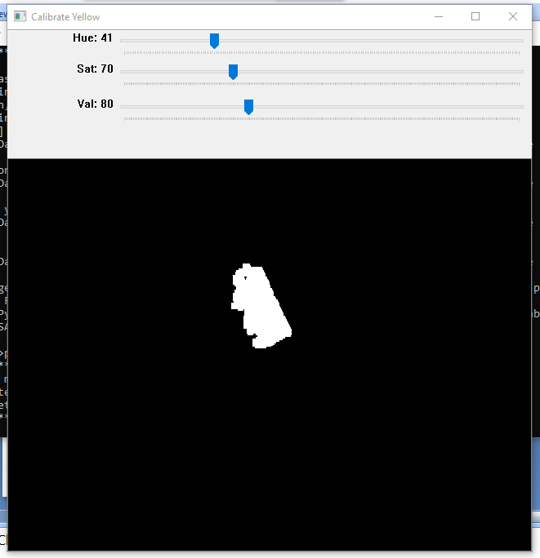

**Fig 5.2.1 Calibrating Yellow color**

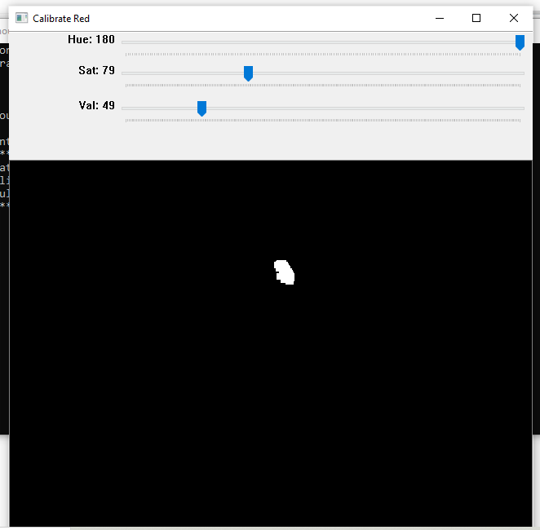

**Fig 5.2.2 Calibrating Red Color**

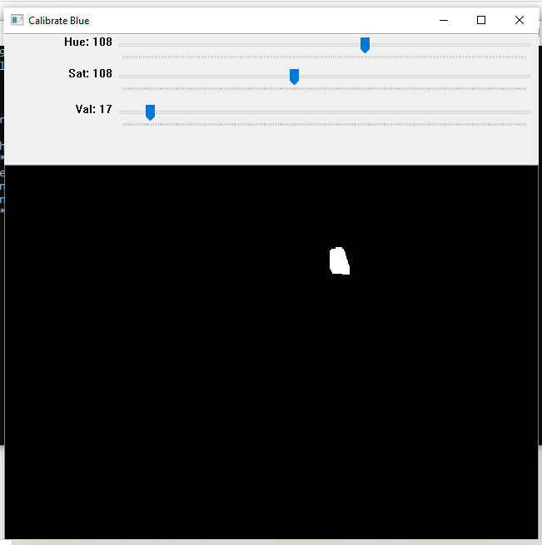

**Fig 5.2.3 Calibrating Blue color**

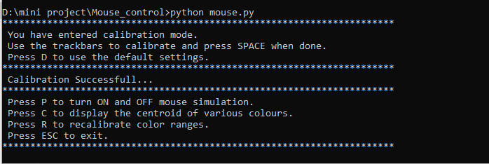

**Fig 5.2.4 Calibration Successful**

**5.2.2 Capturing the Image**

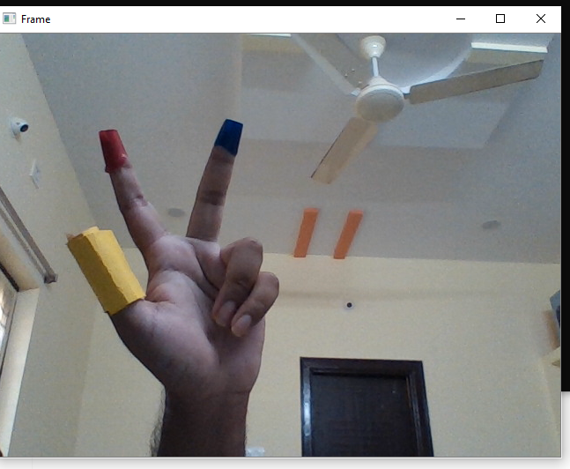

**Fig 5.2.5 Capturing Frame**

**5.2.3 Centroid Recognition**

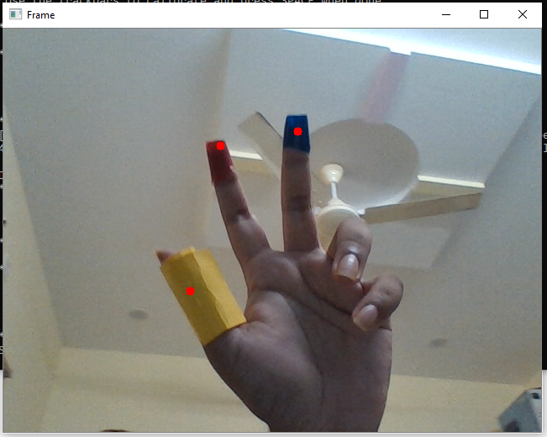

**Fig 5.2.6 Centriod Detection**

**5.2.4 Gestures for Actions**

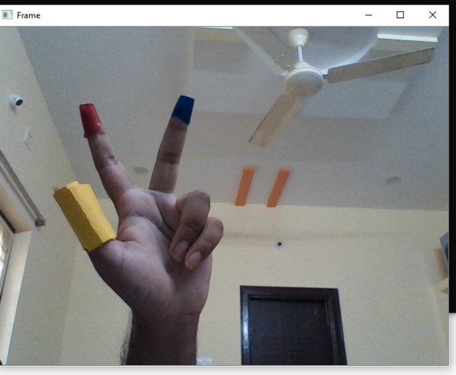 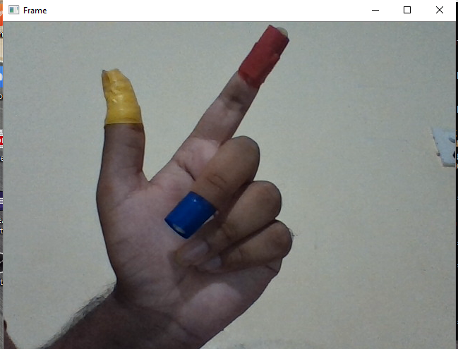

**Fig 5.2.7 Free Movement Fig 5.2.8 Scroll Up**

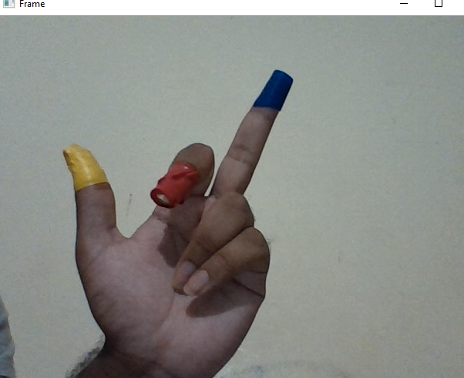

**Fig 5.2.9 Scroll Down**

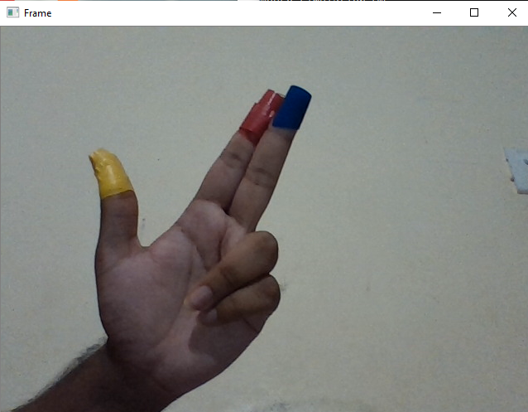 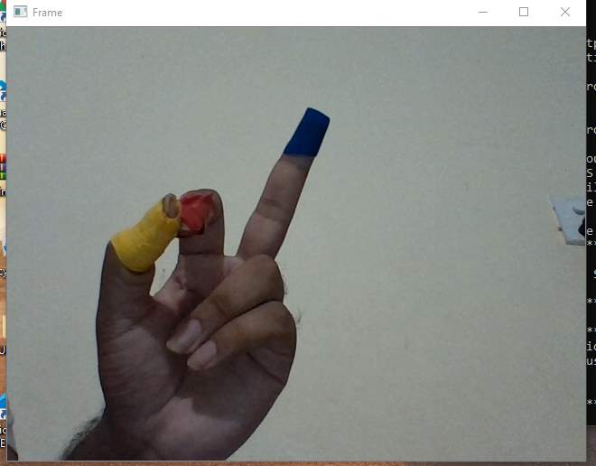

**Fig 5.2.10 Left Click Fig 5.2.11 Right Click**

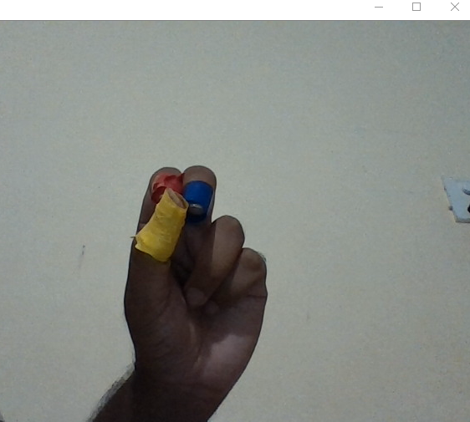

**Fig 5.2.12 Select/Drag**

**5.2.5 Mouse Events**

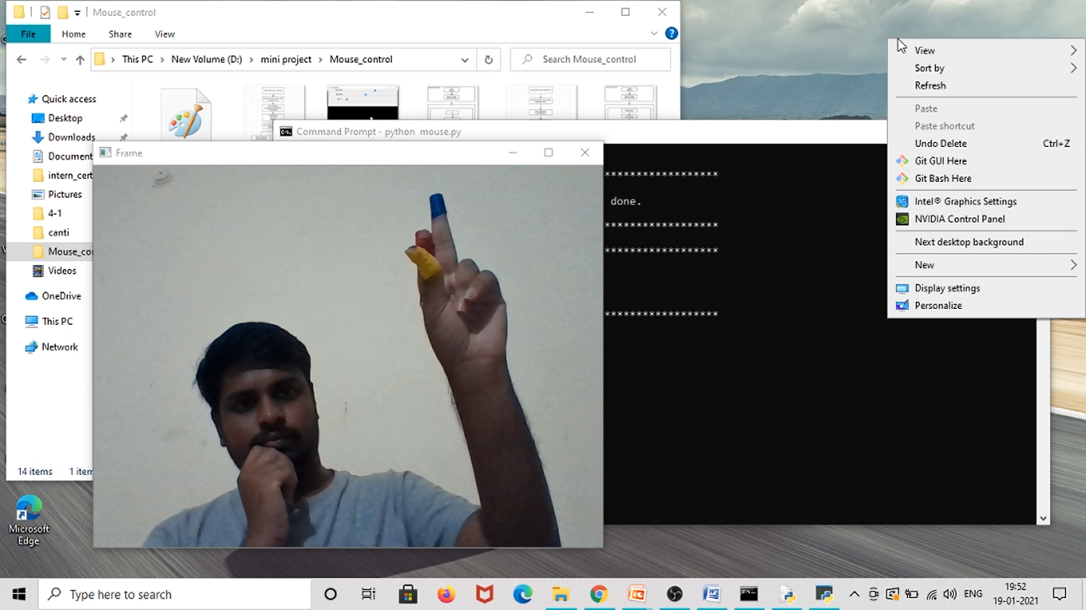

**Fig 5.2.13 Right Click Event**

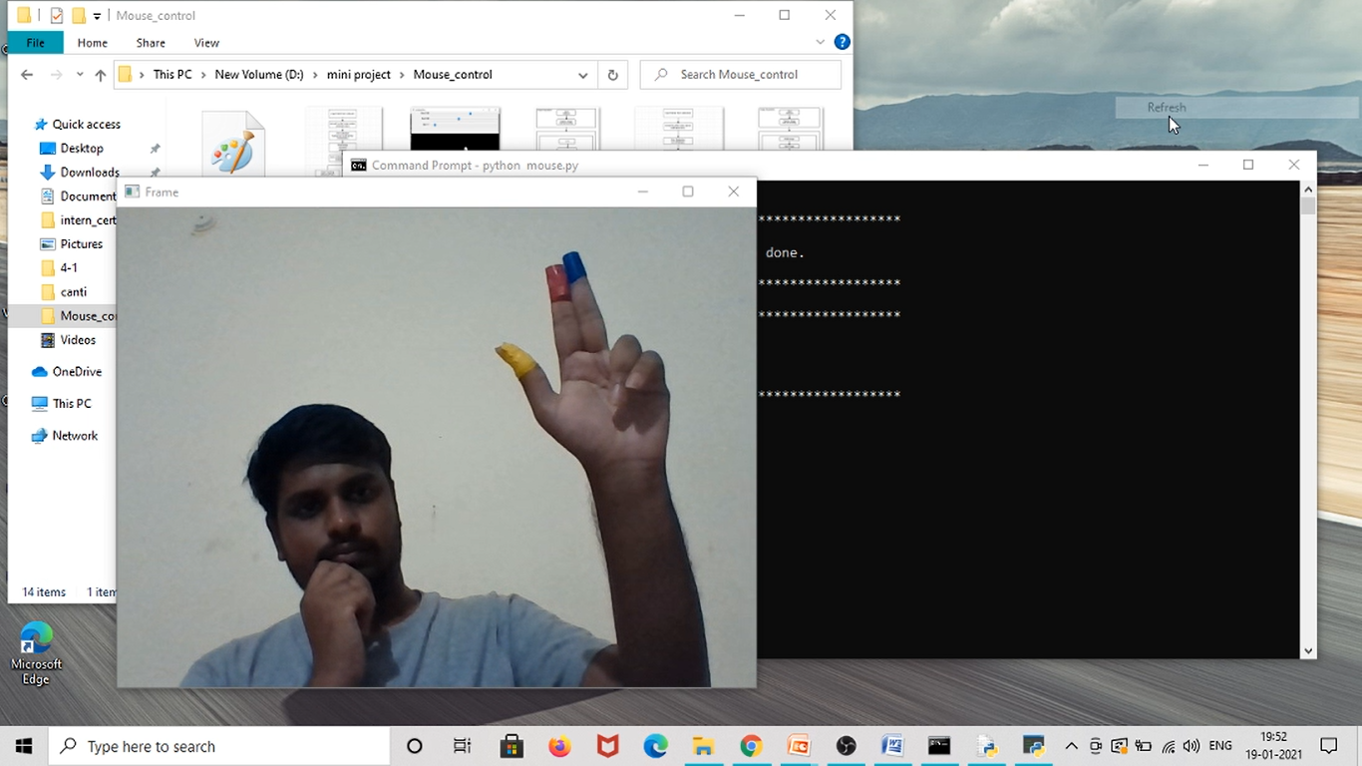

**Fig 5.2.12 Left Click Event**

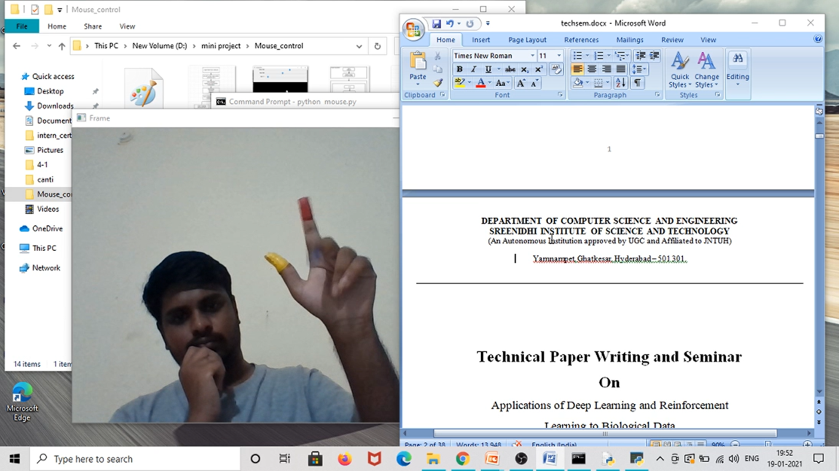

**Fig 5.2.15 Before Scroll Up Event**

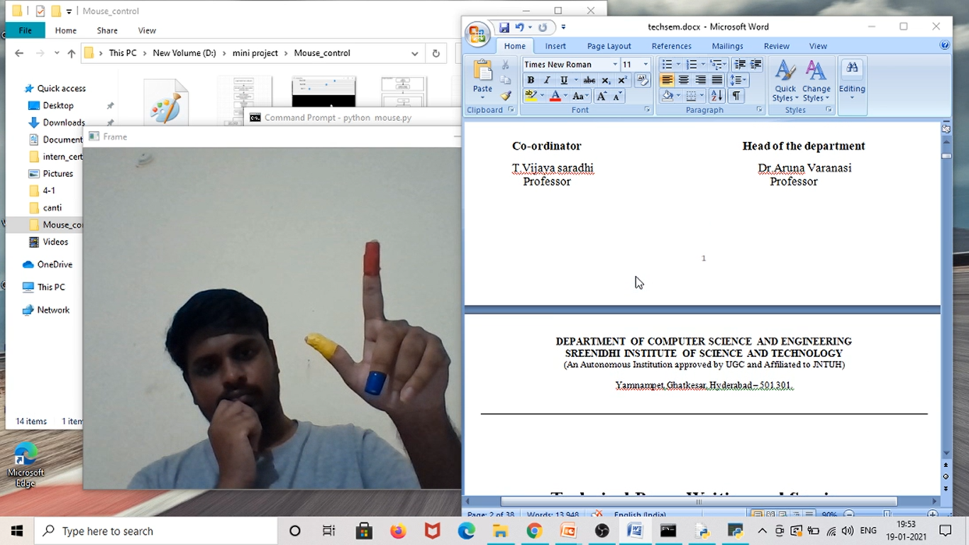

**Fig 5.2.16 After Scroll Up Event**

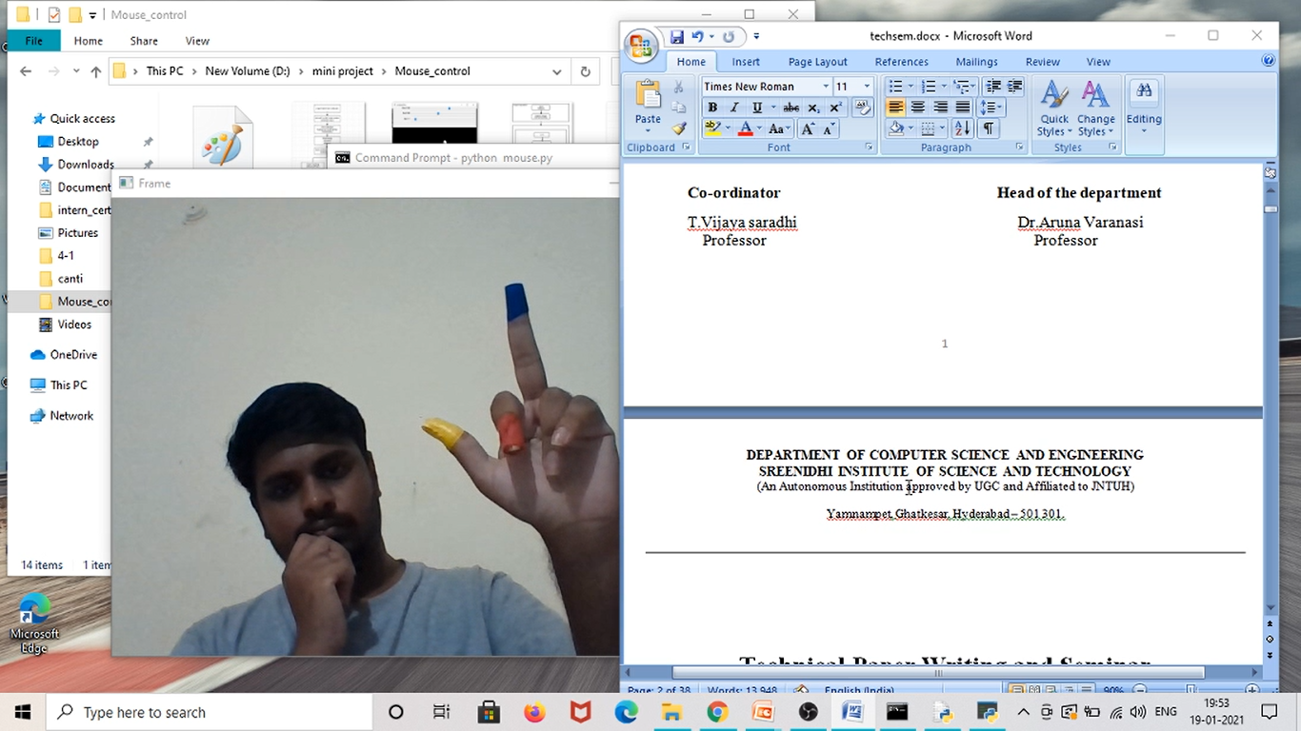**Fig 5.2.17 Before Scroll Down Event**

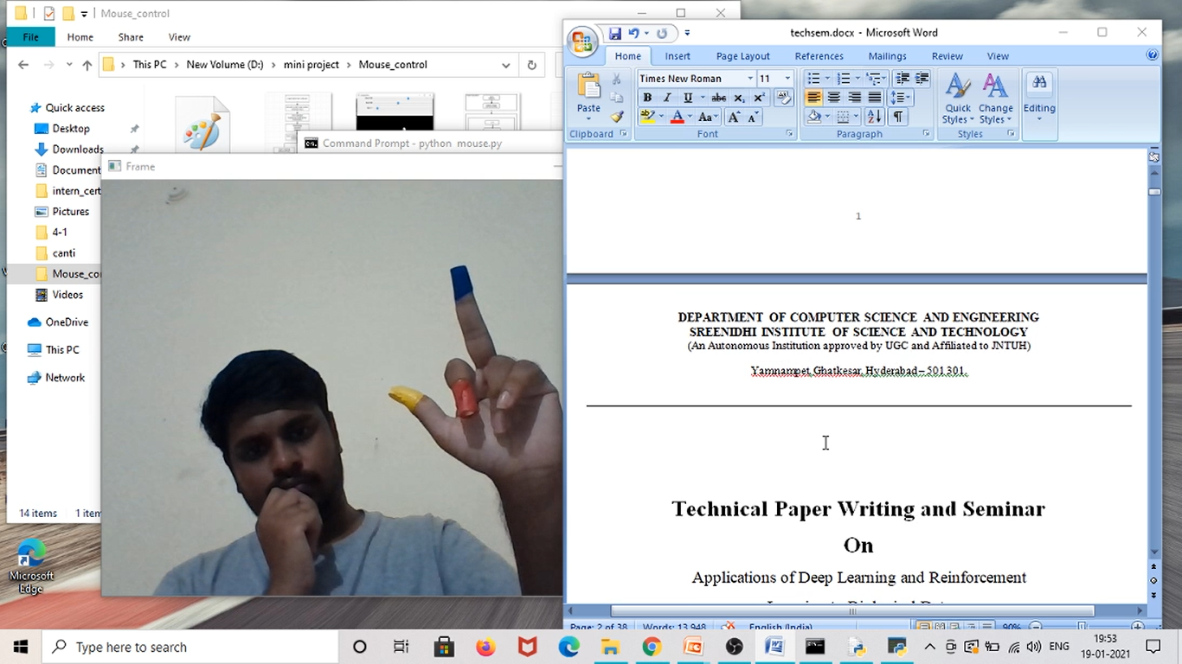 **Fig 5.2.18 After Scroll Down Event**

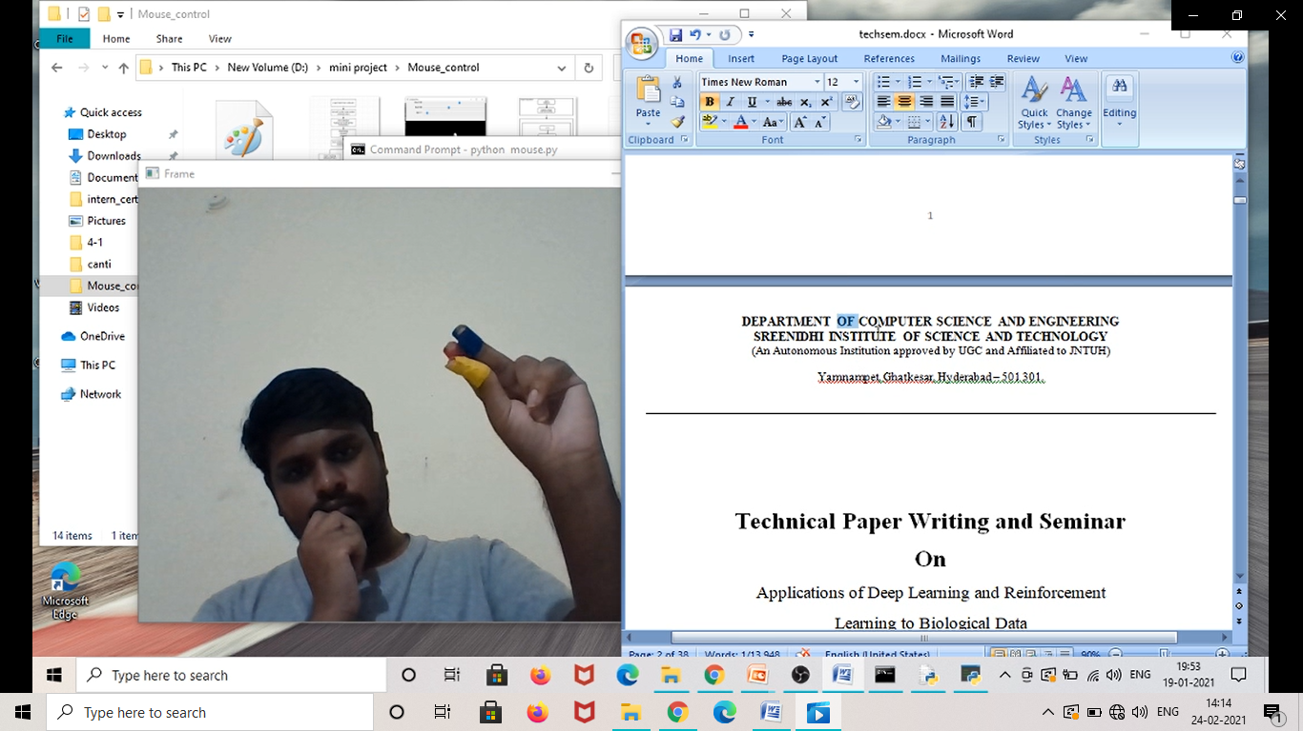

**Fig 5.2.19 Drag/Select Event**

**6. TESTING**

**6.1 Types of Testing**

We have implemented Integration testing and Regression testing methodologies for testing the working of this project. In the Integration testing we tested the code for each module and then integrated them based on the hierarchy to top and tested the final code to verify it passes all of the test cases. As we were doing Integration testing, we identified few bugs in final code and then we modified the code and retested it again and again until it satisfied all test cases.

**6.2 List of Test Cases**

|  |  |  |  |
| --- | --- | --- | --- |
| **S.NO** | **Description** | **Cursor Status** | **Test Case Result** |
| 1 | Test Case with only blue and red colors | No movement of cursor or Action | PASS |
| 2 | Test Case with only yellow and red colors | Only Cursor Movement  No Actions performed | PASS |
| 3 | Test Case with only yellow and blue colors | Only Cursor Movement  No Actions performed | PASS |
| 4 | Test Case with only red color | No movement of cursor or Action | PASS |
| 5 | Test Case with only blue red color | No movement of cursor or Action | PASS |
| 6 | Test Case with only yellow color | Only Cursor Movement  No Actions performed | PASS |
| 7 | Test Case with all the three colors | Free cursor Movements and Actions are performed | PASS |

**Table 6.2 List of Test Cases**

**7. CONCLUSION AND FUTURE SCOPE**

**7.1 Conclusion**

Hand gesture tracking mouse control is developed using python language and OpenCv library. Using this model the system can perform all the mouse events and mouse movements without the need of the actual mouse. The system can control the Cursor by recognizing the hand of the user. And for every cursor function or mouse event a unique hand gesture is provided.

This developed model has the potential to replace the actual mouse but because of few constraints or drawbacks it cannot completely replace the mouse. If those drawbacks are tackled then it can completely replace the mouse. There are different tools for gesture recognition. We have used multiple functions from computer vision library and developed a model by tackling few limitations that are present in previous object tracking models.

**7.2 Future Work**

The problem with this model is that it works well only in a room with good lighting. If the lighting in the room is not good then its performance also decreases. Only because of this reason it cannot completely replace an actual mouse, as people generally use laptops in the outdoor environment as well where the lighting is not good. Therefore further improvements can be made to use it in the bad lighting environments as well. And improvements can also be made such that the three color bands are not required.

It can be further developed with AR technology for more human-machine interaction like in video games etc. More Gestures can be developed where each unique gesture can open certain applications.

**8. BIBLIOGRAPHY**

* 1. <https://ieeexplore.ieee.org/document/9137854>

Proceedings of the Fifth International Conference on Communication and Electronics Systems (ICCES 2020) IEEE Conference Record # 48766; IEEE Xplore ISBN: 978-1-7281-5371-1

* 1. <https://towardsdatascience.com/tagged/dilation-and-erosion?gi=8c4b4c9578c>
  2. <https://globalaihub.com/image-processing-color-spaces-rgb-hsv-and-cmyk-%F0%9F%8C%88/>
  3. www.wikipedia.org

**APPENDIX-A: Python Modules**

**About PyAutoGui:**

PyAutoGUI lets your Python scripts control the mouse and keyboard to automate interactions with other applications. The API is designed to be as simple. PyAutoGUI works on Windows, macOS, and Linux, and runs on Python 2 and 3.

PyAutoGUI has several features:

Moving the mouse and clicking or typing in the windows of other applications.

Sending keystrokes to applications (for example, to fill out forms).

Take screenshots, and given an image (for example, of a button or checkbox), find it on the screen.

Locate an application’s window, and move, resize, maximize, minimize, or close it (Windows-only, currently)

Display message boxes for user interaction while your GUI automation script runs.

**About Opencv (cv2):**

OpenCV-Python is a library of Python bindings designed to solve computer vision problems.

* Python is a general purpose programming language started by **Guido van Rossum** that became very popular very quickly, mainly because of its simplicity and code readability. It enables the programmer to express ideas in fewer lines of code without reducing readability.
* Compared to languages like C/C++, Python is slower. That said, Python can be easily extended with C/C++, which allows us to write computationally intensive code in C/C++ and create Python wrappers that can be used as Python modules. This gives us

two advantages: first, the code is as fast as the original C/C++ code (since it is the actual C++ code working in background) and second, it easier to code in Python than C/C++. OpenCV-Python is a Python wrapper for the original OpenCV C++ implementation.

* OpenCV-Python makes use of **Numpy**, which is a highly optimized library for numerical operations with a MATLAB-style syntax. All the OpenCV array structures are converted to and from Numpy arrays. This also makes it easier to integrate with other libraries that use Numpy such as SciPy and Matplotlib.

**APPENDIX-B: UNIFIED MODELING LANGUAGE**

The Unified Modeling Language (UML) is a general-purpose visual modeling language that is used to specify, visualize, construct, and document the artifacts of a software system. It captures decisions and understanding about systems that must be constructed. It is used to understand, design, browse, configure, maintain, and control information about such systems. It is intended for use with all development methods, lifecycle stages, application domains, and media. The modeling language is intended to unify past experience about modeling techniques and to incorporate current software best practices into a standard approach. UML includes semantic concepts, notation, and guidelines. It has static, dynamic, environmental, and organizational parts. It is intended to be supported by interactive visual modeling tools that have code generators and report writers. The UML specification does not define a standard process but is intended to be useful with an iterative development process. It is intended to support most existing object-oriented development processes.

The UML captures information about the static structure and dynamic behavior of a system. A system is modeled as a collection of discrete objects that interact to perform work that ultimately benefits an outside user. The static structure defines the kinds of objects important to a system and to its implementation, as well as the relationships among the objects. The dynamic behavior defines the history of objects over time and the communications among objects to accomplish goals.

Modeling a system from several separate but related viewpoints permits it to be understood for different purposes.

The UML also contains organizational constructs for arranging models into packages that permit software teams to partition large systems into workable pieces, to understand and control dependencies among the packages, and to manage the versioning of model units in a complex devement environment. It contains constructs for representing implementation decisions and for organizing run-time elements into components.

UML is not a programming language. Tools can provide code generators from UML into a variety of programming languages, as well as construct reverse engineered models from existing programs. The UML is not a highly formal language intended for theorem proving. There are a number of such languages, but they are not easy to understand or to use for most

purposes. The UML is a general-purpose modeling language. For specialized domains, such as GUI layout, VLSI circuit design, or rule-based artificial intelligence, a more specialized tool with a special language might be appropriate. UML is a discrete modeling language.

It is not intended to model continuous systems such as those found in engineeringand physics. UML is intended to be a universal general-purpose modelinglanguage for discrete systems such as those made of software, firmware, or digitallogic.











